**Министерство образования РД МКОУ «Кюрягская средняя общеобразовательная школа»**

**Конкурсная работа**

**на тему:**

**«Мой горный край»**

**в номинации «Авторское стихотворение»**

**название стихотворения : « Мой Табасаран»**

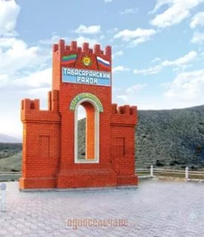 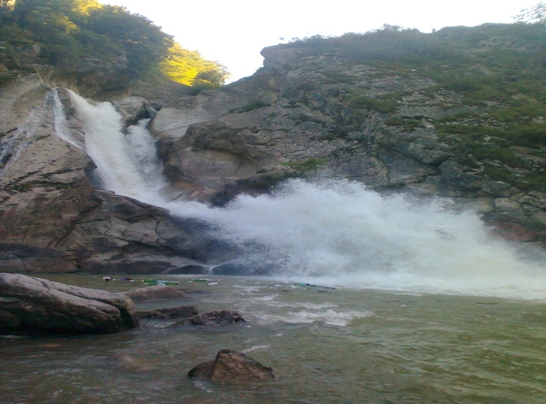

**Подготовила: ученица 8 кл. Гаджикеримова Милена Ризвановна, МКОУ «Кюрягская СОШ»**

**Руководитель: Рашидова Айханум Рамазановна,замдиректора по УВР**

**Контактный телефон: 89640121540**

**Адрес: с. Кюряг, Табасаранский р-н, РД.**

**Адрес элетрон. почты: raikhanum77@mail.ru**

**2016 г.**

MY TABASARAN

The place so precious, sweet and dear,

Where father’s home and friends, and family are near,

I glorify and sing of you,

Tabasaran, I really think so much of you.

The place we call a motherland

Is really for so happy time to spend,

With its forests and rivers to gaze at,

And with your mom to walk by the cascade.

Tabasaran, you’re my home,

I cherish you with all my soul.

As I was brought to birth by you,

I’am proud to be a part of you.

All the fellow – villagers of mine

Always taught to love the dearest clime,

Giving me instructions all the time:

“ Homeland, dear, you must never leave behind”.

We live in line with our laws,

As real mountaineers.

We hand down our mother tongue

A year after year

And hold the memory of ancestors, so dear.

Tabasaran’s forewer our home, it’s clear.

